PRESS RELEASE

COMMUNICATIONS AND MEDIA TEAM OF THE 43RD ASEAN SUMMIT 2023

No.45/SP/TKM-ASEAN2023/ENG/9/2023

ASEAN Countries Eye Property and Renewable Energy Investments in IKN

Jakarta, 3 September 2023 – The Nusantara Capital City Authority (OIKN) has recorded a total of Rp20 trillion in private investments in the entertainment sector in the Nusantara Capital City (IKN), which is nearly about a quarter of the total required private development funding.

"For private investments, we already have around Rp20 trillion. It’s mainly play which includes entertainment, hotels, and also green open spaces," said Deputy for Funding and Investment of the Nusantara Capital City Authority (OIKN) Agung Wicaksono, after speaking at the ASEAN Investment Forum Day 2 in Jakarta on Sunday, 3 September 2023.

Agung further revealed that they have received 270 letters of intent (LOI) for IKN from prospective investors, both from domestic and international investors.

"In more than half of the play, the biggest portion came from Indonesian companies. Followed by ASEAN countries Singapore and Malaysia. Also included in the largest five investors are Japanese and South-Korean companies," he said.

In terms of investment from ASEAN countries, in particular, two property companies from Malaysia have committed to building 20 apartment towers or flats in the IKN. These two companies are currently conducting feasibility studies and are awaiting government evaluations before obtaining licenses to begin construction.

"As for Singapore, they are most interested in renewable energy and waste processing," he added.

Agung mentioned that in the National Medium-Term Development Plan (RPJMN) 2020-2024, the total funding requirement for IKN is listed at Rp466 trillion, which is divided into three funding sources: Rp90.4 trillion from the state budget (APBN), Rp123.2 trillion from businesses/private sector, and Rp252.5 trillion from Public-Private Partnerships (PPP).

The private funding, dominated by domestic private sectors, primarily goes to zone 1A, which will be the location for the Presidential Palace and several ministry offices.

"Zone 1 is for the area similar to the current Jakarta area where the state palace, Monas (National Monument), and so on, are. Let’s focus there first, the Central Government Core Area (KIPP) which is arranged to cover about 6,000 hectares. We will focus on KIPP's area 1A in 2024. We will set more targets afterwards," he said. (Kuntum Khaira Riswan/Faisal Yunianto/Elvira Inda Sari/PR)

***

For more information, please contact:
Director General of Public Information and Communications of the Ministry of Communications and Informatics – Usman Kansong (0816785320).

Get more information at http://asean2023.id, https://infopublik.id/kategori/asean-2023, and https://indonesia.go.id/kategori/ragam-asean-2023

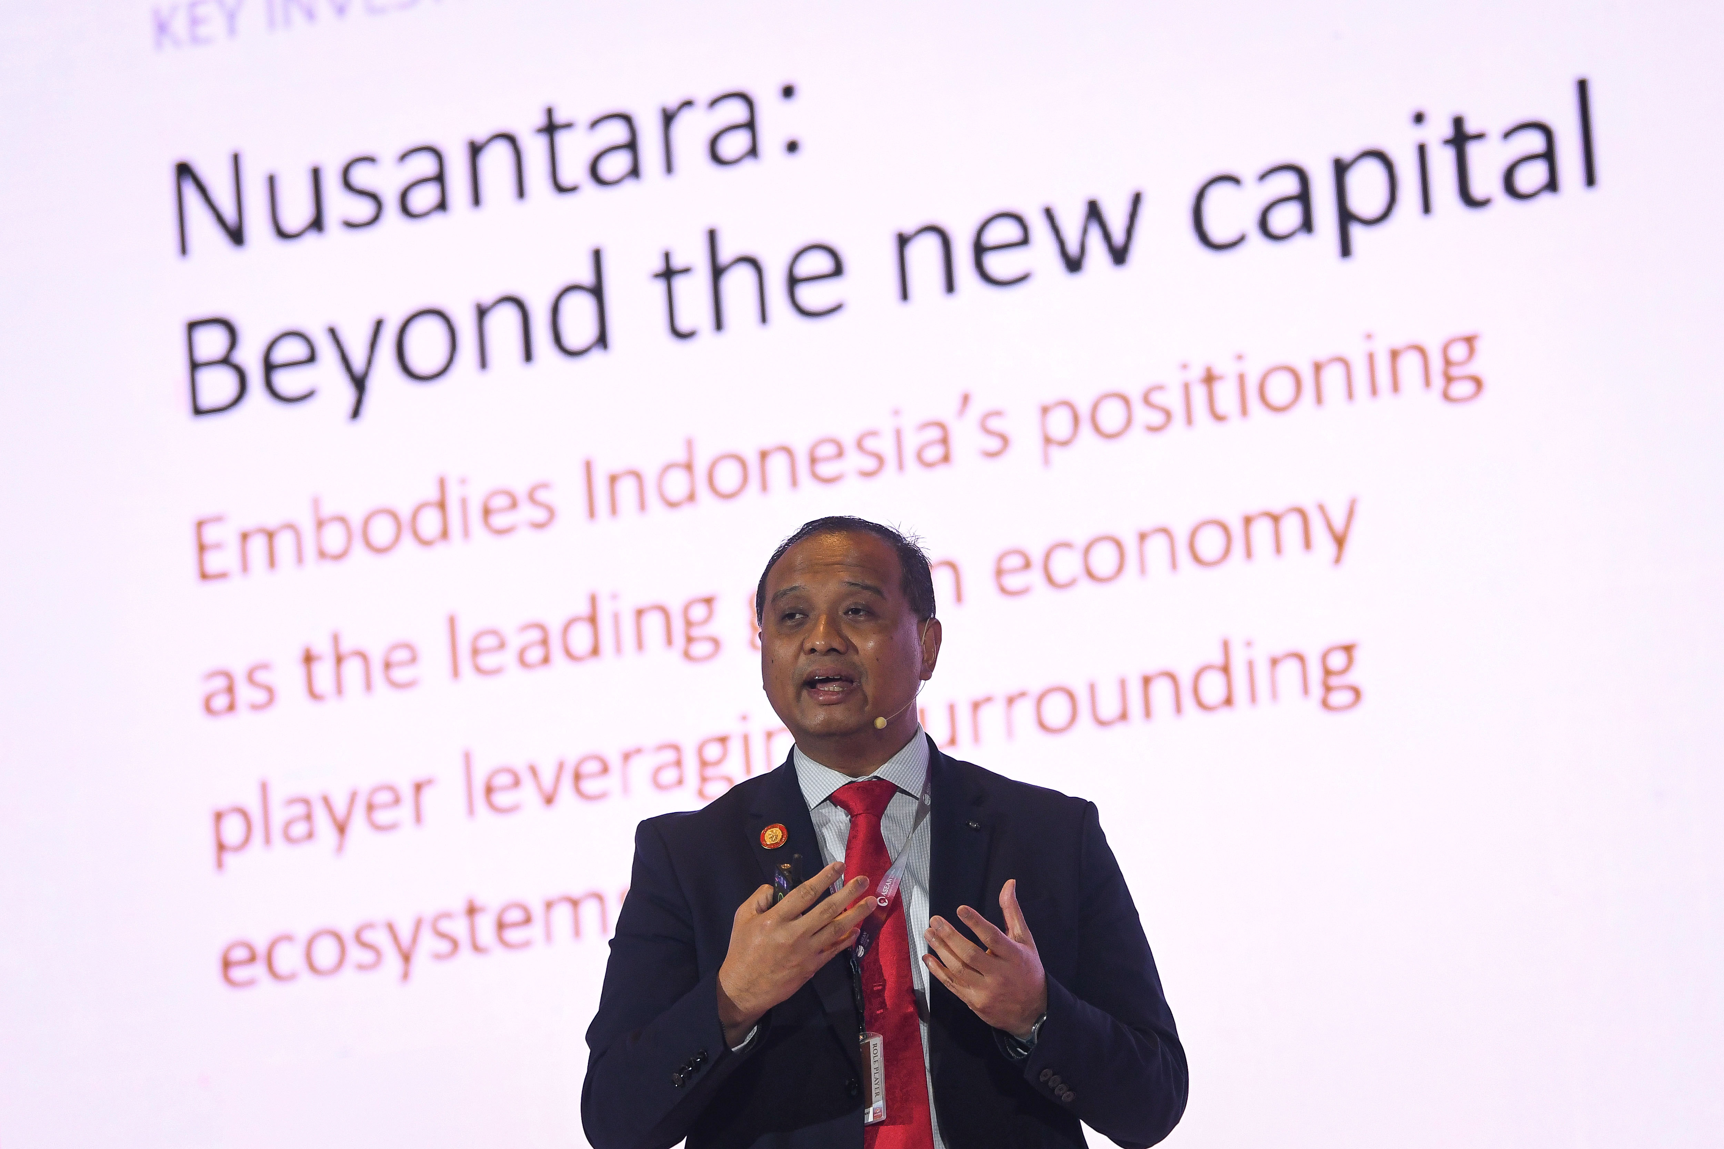

Deputy for Funding and Investment of the Nusantara Capital City Authority (OIKN) Agung Wicaksono, delivers a presentation on Day 2 of the ASEAN Investment Forum at the Sultan Hotel in Senayan, Jakarta, Sunday (3/9/2023). Media Center KTT ASEAN 2023/Aditya Pradana Putra/pras.

